Multimodal Prediction of Short-Horizon Equity Returns Using Financial Statements and Textual Disclosures

1. Introduction
Financial markets respond rapidly to new information, especially around scheduled earnings announcements. These events release both structured numerical information (such as revenue, earnings, margins, and cash flows) and unstructured textual information (such as management commentary). While most studies examine these information sources in isolation, relatively few investigate whether combining them improves short-horizon return prediction under realistic, leakage-free conditions.
This project investigates whether a strict modeling pipeline, based on strong numerical baselines combined with economically motivated feature engineering, can generate meaningful predictive signals around earnings events. The methodology deliberately emphasizes conservative design principles: interpretable features, strict timestamp alignment, and extensive testing for potential information leakage. Rather than expecting high predictability, the objective is to understand how much genuine signal can realistically be extracted once common sources of bias and leakage are removed.
The modeling pipeline evolved dynamically throughout the project. Early numeric baselines produced results barely better than chance. We then introduced several refinements, including market-adjusted targets, expectation-based features, and event-specific engineering. These changes produced unexpectedly strong improvements in predictive performance, which immediately raised concerns regarding potential data leakage. As a result, extensive robustness checks were conducted. No evidence of leakage was found. Instead, the performance gains appear to stem from more accurate modeling of market expectations and surprise dynamics.

2. Dataset Construction and Experimental Setup

2.1 Dataset Construction
The dataset is constructed at the firm-quarter event level, where each observation corresponds to a single earnings disclosure and is indexed by its announcement date. Structured numerical features are derived from income statements, balance sheets, and cash flow statements. Market benchmark data is used to compute abnormal returns.
The full dataset contains 34,288 earnings events from 2005 to 2025, covering 658 individual firms. After filtering out observations with missing values in the modeling features, 31,475 observations remain for analysis. All data are sourced from FinancialModelingPrep.com.

2.2 Experimental Design
Events are sorted chronologically, and all experiments follow a strict walk-forward, year-by-year evaluation scheme. For each test year, models are trained exclusively on all prior years, ensuring that predictions are generated strictly out-of-sample. This setup prevents look-ahead bias and closely reflects a realistic forecasting scenario.

2.3 Prediction Target
The prediction target is the three-day forward abnormal return following the earnings announcement:
$$\text{unexpected_abnormal_ret}=\text{firm 3-day return}-\text{market 3-day return}-\text{pre-event drift}.$$
This formulation isolates the firm-specific price reaction by removing overall market movements and short-term price trends. Summary statistics confirm that the target is well-behaved, with mean near zero and realistic volatility.

2.4 Evaluation Metrics
Model performance is assessed using:
- Mean Absolute Error (MAE)
- Root Mean Squared Error (RMSE)
- R² (coefficient of determination)
- Hit rate, defined as the fraction of predictions that correctly match the sign of the realized return.
Given the inherent noise of short-horizon return prediction, hit rate is treated as the primary economic performance metric.

3. Numeric-Only Baseline Models

3.1 Numeric Baselines and Economically Motivated Feature Engineering
Initial numeric baselines were constructed using standard accounting variables, including revenue, earnings per share (EPS), margins, cash flows, leverage, and liquidity. These models exhibited weak predictive performance. Linear regression achieved hit rates of only 51–52%, with near-zero or negative R², while more flexible nonlinear models such as LightGBM failed to improve results and frequently overfit. These outcomes align with the efficient market hypothesis, suggesting that most raw accounting information is rapidly anticipated and incorporated into prices.
To better reflect how markets process earnings information, the feature set was redesigned using economically motivated principles.
First, explicit expectation modeling was introduced. For each firm and key accounting variable (EPS, revenue, EBITDA, operating income, and free cash flow), rolling exponentially weighted moving average (EWMA) expectations were constructed using only historical data. Rolling standard deviations were then computed to form standardized surprise measures:
$$\text{surprise}=\frac{\text{actual}-\text{expected}}{\text{rolling }\text{volatility}}.$$
This formulation captures how unusual reported values are relative to a firm’s own historical behavior.
Second, cross-sectional surprise context was added by benchmarking firm-level surprises against other companies reporting in the same fiscal year and quarter. This provides a proxy for relative performance within a peer group.
Third, quality and structural indicators were incorporated, including gross and operating margins, quarter-over-quarter margin changes, accruals ratios (earnings quality), net debt to assets, and cash to assets. These variables capture deeper aspects of profitability, balance sheet strength, and earnings reliability.
Finally, market-based expectation proxies were introduced, including pre-event price drift, recent abnormal returns, and short-horizon news flow metrics. All market features were carefully lagged to ensure that only information available prior to the earnings announcement was used, preventing any form of look-ahead bias.
Together, these refinements substantially strengthened the numeric modeling pipeline by aligning features more closely with how markets form expectations and respond to earnings surprises.

3.3 Walk-Forward Modeling Results
Using this refined feature set and strict walk-forward evaluation, the following average out-of-sample performance for 2010–2025 was obtained:
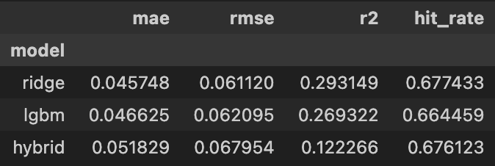
This represents a substantial improvement over the initial numeric baselines, which achieved only 51–52% hit rates. Ridge regression exhibits the strongest overall performance and is therefore adopted as the primary numeric benchmark.

3.4 Selective Prediction Performance
A selective prediction strategy was used to evaluate whether the model can identify high-confidence predictions. Confidence is defined as the absolute magnitude of predicted returns, and only predictions exceeding a chosen confidence threshold are evaluated.
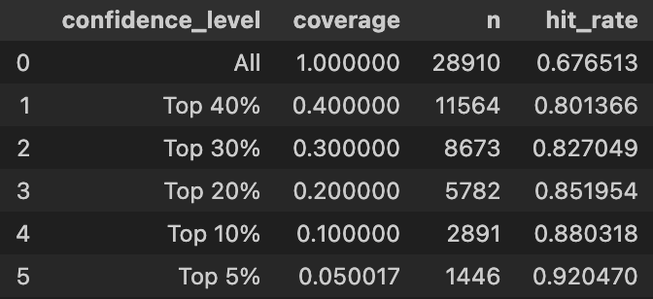
Focusing on the top 10% most confident predictions yields nearly 88% directional accuracy, while the top 5% exceed 92%. This demonstrates that the model is particularly effective at identifying situations where earnings surprises contain strong informational value.

4. Data Leakage Investigation
The unexpectedly strong results prompted a rigorous investigation into potential data leakage. For short-horizon equity prediction, average hit rates near 68% and exceeding 85% in high-confidence subsets are unusually high. A comprehensive leakage audit was conducted, consisting of the following tests:

Feature Audits
- Verified that no forward returns (ret_3d, abnormal_ret_3d, unexpected_abnormal_ret) appear in the feature set.
- Confirmed that all rolling expectations and standard deviations are properly lagged, ensuring only historical data is used.
- Confirmed that cross-sectional surprise measures rely solely on contemporaneous quarter medians.
- Verified that all price-based features are strictly lagged.

Temporal Stress Tests
Pre-event price features were shifted backward by 2–3 days instead of 1, producing a clear drop in performance. This confirms that feature timing is correct and that the model is not inadvertently capturing post-announcement price reactions.

Randomization Tests
The target variable was randomly shuffled and the model retrained. Hit rates collapsed to ~49.6%, consistent with random guessing, demonstrating that the pipeline does not artificially inject predictive signal.

Baseline Sanity Checks
An always-long strategy achieved a hit rate of only 49.3%, confirming that directional bias cannot explain the results.
Together, these tests provide strong evidence that data leakage is not responsible for the observed predictive performance. Instead, the gains appear to result from explicit modeling of expectations, volatility, and surprise dynamics.

5. Discussion and Interpretation
The central insight from this work is that markets respond primarily to deviations from expectations rather than to raw fundamentals. By explicitly modeling firm-specific expectations and volatility, earnings announcements reveal substantially stronger predictive signals than initially observed.
Furthermore, selective prediction results highlight the heterogeneity of market reactions. While most earnings events carry limited actionable signal, a subset of extreme surprises generates strong and highly predictable price responses.
These findings establish a robust and economically meaningful numeric baseline. They also define a demanding benchmark for subsequent multimodal modeling experiments. Any improvement from incorporating textual embeddings must exceed this already strong numerical foundation, making further gains both more challenging and more meaningful.

4. Text-Only Baseline Models
This section examines whether earnings-related textual disclosures contain predictive information beyond what is already captured by numerical financial data. Unlike structured accounting records, earnings call transcripts and managerial commentary provide forward-looking guidance, explanations of firm performance, and strategic framing, which may influence short-term market reactions. However, these qualitative signals are difficult to quantify using traditional modeling approaches.
To evaluate the predictive value of text, each earnings disclosure is encoded using FinBERT, a transformer model pretrained on financial corpora. For each document, a 768-dimensional dense embedding is extracted and used as the sole model input. These embeddings capture a condensed semantic representation of the text, incorporating tone, emphasis, and contextual meaning. The prediction task and evaluation framework mirror those used in the numeric experiments, employing a strict walk-forward, year-by-year evaluation and the same abnormal return target.

4.1 Initial Text-Only Baselines
The simplest text-only baseline trains a ridge regression model directly on the FinBERT embeddings. This approach mirrors the linear numeric baseline and serves as a transparent benchmark for evaluating whether raw text embeddings contain meaningful predictive signal.
The resulting performance is modest. The model achieves an MAE of approximately 0.052, an RMSE of around 0.070, and a hit rate of roughly 52.0%, with a slightly negative R². While the hit rate marginally exceeds random guessing, the improvement is small and unstable. More complex nonlinear models, such as multilayer perceptrons (MLPs), were also tested but consistently overfit and exhibited significantly worse generalization performance.
These results indicate that although earnings-related text contains some weak directional information, the signal is highly diffuse. Compared to financial statement data, textual disclosures are inherently noisy, stylistically diverse, and less temporally aligned across firms. This makes it difficult for standard regression models to extract stable predictive patterns from high-dimensional embedding representations.

4.2 Attempted Text Expectation Modeling
Motivated by the substantial improvements obtained for numerical features through explicit modeling of expectations and surprises, we attempted to extend this framework to textual data. The goal was to isolate unexpected changes in narrative tone or content, rather than relying solely on raw embeddings.
For each firm, rolling exponentially weighted moving average (EWMA) expectations of text embeddings were computed using only past disclosures. This produced a firm-specific textual baseline representing the company’s typical communication style and tone. Based on this baseline, standardized textual surprise measures were constructed:
$$\text{text} \text{surprise}=\frac{\text{current embedding}-\text{expected embedding}}{\text{rolling }\text{volatility}}$$
In addition, cross-sectional surprise features were derived by comparing each firm’s textual surprise to the distribution of surprises among firms reporting in the same quarter. This was intended to capture whether a firm’s narrative was unusually positive or negative relative to peers.
In contrast to the numeric case, these expectation-based text features failed to improve predictive performance. In fact, they consistently degraded results, reducing hit rates to approximately 50% and eliminating the limited signal observed in the original baseline. Several factors likely contribute to this outcome. First, text embeddings are extremely high-dimensional, meaning that small variations in phrasing can dominate true shifts in narrative content. Second, managerial language evolves gradually and is heavily influenced by firm culture, executive leadership, and disclosure strategy, making stable historical baselines difficult to define. Finally, short-horizon market reactions appear to respond more strongly to quantitative surprises than to subtle changes in narrative tone.
Given these limitations, expectation-based textual modeling was ultimately abandoned.

4.3 Final Text-Only Baseline
After extensive experimentation, the strongest text-only model remains the ridge regression trained directly on FinBERT embeddings, without any expectation-based transformations. This approach provides a simple, stable baseline that captures the weak but non-random directional signal present in earnings disclosures.
To evaluate whether model confidence is informative, a selective prediction strategy is applied. Model confidence is measured by the absolute magnitude of predicted returns, and performance is evaluated on increasingly confident subsets.
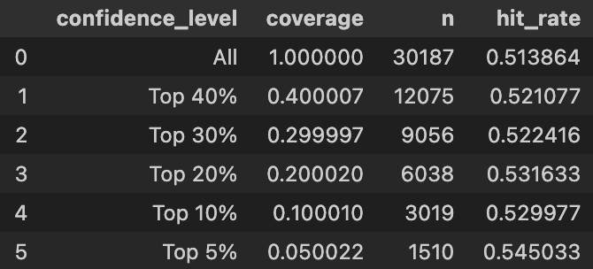
Directional accuracy improves modestly as predictions are restricted to higher-confidence events, reaching approximately 54–55% for the most confident 5% of predictions. While this improvement remains limited compared to the numeric baseline, it suggests that textual disclosures contain weak but non-random predictive information, particularly in extreme cases.

4.4 Discussion
Overall, text-only models exhibit significantly weaker predictive performance than numeric models. Despite extensive feature engineering and attempts at expectation modeling, textual information alone fails to generate strong or stable short-horizon return forecasts.
This outcome is economically intuitive. Earnings-related text often contains vague, strategic, and carefully framed language that may obscure true firm performance. Moreover, most economically relevant information is already captured in numerical accounting data, leaving limited incremental signal in raw text. Finally, learning robust patterns from high-dimensional embeddings is challenging in noisy financial environments with limited labeled data.
Nevertheless, the improvements observed under selective prediction indicate that textual disclosures can provide useful information in a small subset of extreme events. These findings motivate the use of textual features primarily as complements to strong numerical models, rather than as standalone predictors. This insight naturally motivates the multimodal modeling framework introduced in the following section.

6. Multimodal Modeling
The main objective of this study is to evaluate whether combining numerical and textual information improves predictive performance when both modalities are represented using economically meaningful, expectation-based features. Instead of relying on raw feature concatenation, the multimodal pipeline mirrors the refined baseline logic by explicitly modeling expectations and surprises in both numeric accounting variables and textual disclosures.
For the numerical modality, the strongest baseline specification is retained, incorporating firm-specific rolling expectations, standardized surprise measures, cross-sectional surprise context, quality indicators, and lagged market proxies. Similarly, FinBERT embeddings are transformed using an expectation-based framework. Specifically, rolling firm-level expectations of text embeddings are computed using strictly lagged information, and textual surprise vectors are defined as deviations of realized embeddings from their expected representations. These surprise vectors are then cross-sectionally normalized within each fiscal year to produce standardized text surprise features.
This formulation yields a coherent multimodal representation that emphasizes unexpected informational content, consistent with economic theory. Final multimodal feature vectors are constructed by combining numeric surprise features with standardized textual surprise embeddings. Several fusion strategies are evaluated under a strict year-by-year walk-forward framework, including ridge regression, nonlinear tree-based models, a hybrid sign–magnitude approach, and selective prediction.

6.1 Structured Multimodal Fusion

Ridge Regression Fusion
Ridge regression provides a stable linear multimodal baseline. Averaged across the test years, ridge fusion achieves:
- MAE: 0.0499
- RMSE: 0.0676
- R²: 0.1918
- Hit rate: 0.641
These results demonstrate that textual surprise features improve performance relative to text-only baselines and provide robust directional accuracy. However, a direct comparison of RMSE across ridge-based models reveals that multimodal ridge does not outperform the numeric-only ridge benchmark, which achieves a lower RMSE of 0.0625, compared to 0.0676 for the multimodal model. This indicates that while text contributes useful directional signal, it introduces additional noise that partially offsets its benefits in squared-error terms.

Nonlinear Fusion with HistGradientBoosting
The strongest multimodal performance is achieved by the nonlinear HistGradientBoosting (HistGB) model, which captures interaction effects between numeric and textual surprise signals. Its aggregate test performance is:
- MAE: 0.0457
- RMSE: 0.0632
- R²: 0.2950
- Hit rate: 0.670
This represents a substantial improvement over linear fusion, particularly in terms of error magnitude and explanatory power. The results suggest that textual information interacts nonlinearly with numerical fundamentals, and that flexible learners are better equipped to extract this complementary signal. Directional accuracy remains consistently strong across test years, frequently exceeding 65% and reaching approximately 70% in several periods, confirming the robustness of the multimodal nonlinear signal.

Hybrid Sign–Magnitude Modeling
A hybrid approach decomposing predictions into sign and magnitude components is also evaluated. While its average global performance is weaker than HistGB and ridge fusion:
- MAE: 0.0562
- RMSE: 0.0738
- R²: 0.0382
- Hit rate: 0.628
the hybrid model exhibits exceptionally strong performance under selective prediction. When only the most confident predictions are considered, directional accuracy increases sharply:
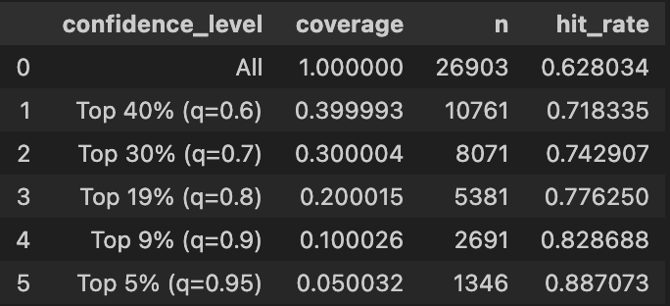

These results demonstrate that while the hybrid model is not optimal as a global forecaster, it is highly effective at identifying extreme earnings events with unusually strong directional signal, supporting its use in selective trading strategies.

Summary of Multimodal Results

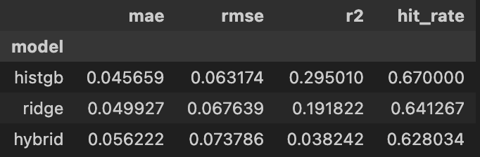

Discussion and Interpretation
The multimodal results provide a refined perspective on the value of combining structured financial variables with textual disclosures for short-horizon stock return prediction. In contrast to naïve fusion strategies, which typically degrade performance, structured multimodal fusion based on expectation modeling yields meaningful improvements—particularly when nonlinear interactions are exploited.
A central finding is that textual disclosures contribute incremental predictive value primarily through nonlinear mechanisms. While ridge regression benefits modestly from adding textual surprise features, the strongest gains emerge under HistGradientBoosting, which captures interactions between accounting surprises and linguistic cues. This suggests that text refines the interpretation of numerical fundamentals rather than acting as an independent signal source, providing contextual nuance that modifies how markets respond to reported results.
However, the comparison between ridge-based numeric-only and multimodal models reveals an important limitation: text does not consistently reduce prediction error. Although multimodal ridge improves directional accuracy, it fails to outperform the numeric-only benchmark in RMSE, indicating that textual features introduce additional noise. This highlights the inherently fragile and diffuse nature of textual signal in financial prediction, particularly in environments characterized by rapid information diffusion and low signal-to-noise ratios.
The hybrid model results further clarify this dynamic. While average performance is inferior to HistGB, the dramatic increase in hit rates under selective prediction indicates that textual information is most valuable in extreme surprise regimes. When earnings announcements contain unusually strong qualitative signals, textual features substantially enhance predictive accuracy, with hit rates exceeding 88% in the top 5% confidence subset. This supports the interpretation that text is particularly informative during rare, high-impact events, rather than in typical earnings releases.
Overall, these findings reinforce a central empirical lesson: predictive success in financial modeling depends more on representation design and noise control than on architectural complexity. Textual disclosures do contain incremental information, but extracting that signal requires disciplined expectation modeling, dimensional control, and nonlinear interaction learning. In weak-signal environments, effective multimodal modeling is achieved through principled structure rather than brute-force complexity.

